# The Odin Project---Landing Page

## Instructions

<https://www.theodinproject.com/lessons/foundations-landing-page>

## Purpose

To build a responsive static webpage with a modern layout using CSS Flexbox as the primary layout method.

## Preview

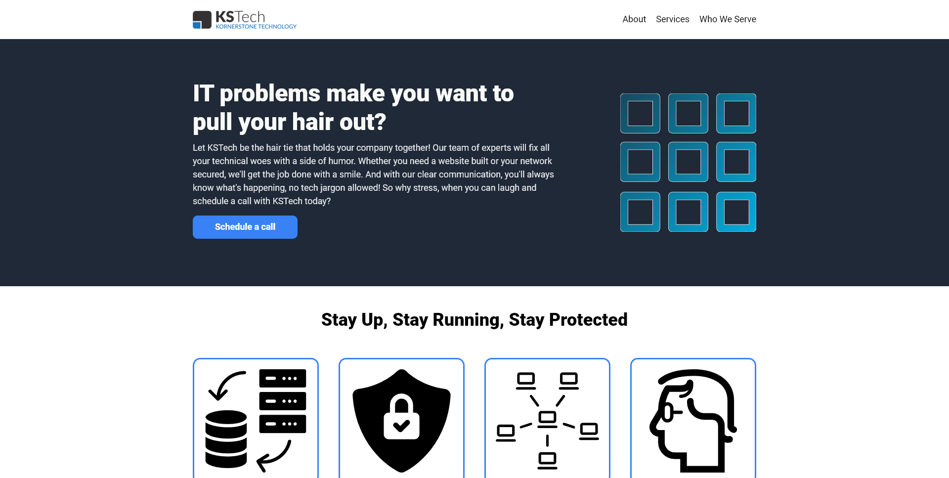

### Technologies:

* HTML icons8-html-5-20
* CSS icons8-css3 Flexbox

### Tools:

* Git icons8-git
* Github icons8-github

### Outcome :ballot_box_with_check:

I created a responsive webpage with a modern layout using CSS Flexbox.

| **Website** | **Link** |
| --- | --- |
| GitHub demo | <https://jaredbradley243.github.io/The-Odin-Project---Landing-Page/> |

## Summary

### What I learned

1. How to create layouts using CSS Flexbox containers and items. How to align, position, and space elements using the Flexbox properties:
   * *flex-direction*
   * *justify-content*
   * *align-items*
   * *flex-wrap*
   * *flex-grow*
   * *flex-shrink*
   * *flex-basis*
   * *align-self*
   * *gap*
2. How to open links in a new browser tab by setting the ***target attribute*** of the <a> tag to _blank
3. How to protect against ***tabnabbing*** by using the ***referrerpolicy*** and ***rel*** attributes
4. How to create a responsive footer using CSS Flexbox
5. How to import and use multiple fonts in a CSS document

### Customizations

* I added a responsive footer with a link to my Github page, with careful attention to protect against tabnabbing.
* I imported *Noto Color Emoji* ***Google Font*** to use more attractive emojis.
* I used ***ChatGPT*** to write all of the sales copy.
* I based the website on an existing company, KSTech, founded by a good friend of mine. See <https://www.kstech.com/> for all of your IT needs!

### What could be improved

* The webpage is static and used only for demo purposes. Adding additional pages and user interaction would improve this project significantly.
* Create a backend using Django or Express to make the project a little more interesting.